🏁 Adutha Step: Indexing & Slicing
Intha "Salary List"-la irundha specific-a orutharoda salary-ai mattum edukkanum na, athu epadi nu paarkkalam.
Example:
- salary_array[0] = First salary (3000)
- salary_array[1:3] = Second and third salary (4000, 5000)
Neenga ippo intha code-la, "print(bonus_salary[0])" nu pottu, output 3000 mattum varudha nu paarunga. Appuram "print(bonus_salary[1:3])" pottu paarunga.
Idhu mudinjadhu, namma "Reshaping" (Array-vai Matrix-a mathurathu) pathi pesuvom. Ready-a Irshad?

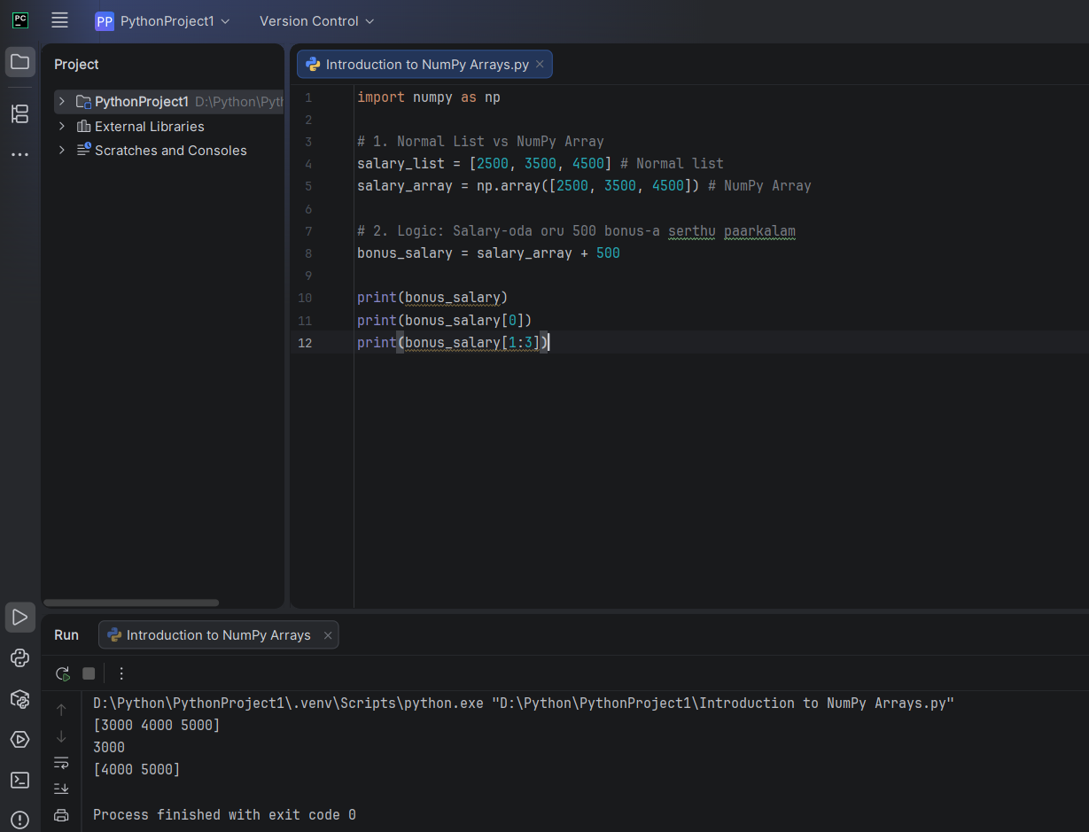
Kavalai padadheenga Irshad! Idhu pala perukku varura sandegam dhaan. Adhai romba simple-a, oru "Train Bogies" (Train petti) kadhaiya vachi purinjipom.
🚂 The Train Concept (Indexing & Slicing)
Oru train-la 3 petti irukkunnu vechukonga. Python/NumPy-la Counting 0-la irundhu dhaan start aagum.
- Petti 0 (Index 0): 3000
- Petti 1 (Index 1): 4000
- Petti 2 (Index 2): 5000
1. Indexing (Oru Petti-ai mattum edukka)
Neenga train-la 1st petti-ai mattum paakanum na, [0] nu kodukkanum.
Python
# [3000, 4000, 5000]
print(bonus_salary[0]) # Output: 3000
print(bonus_salary[2]) # Output: 5000
2. Slicing (Pala Pettigalai "Cut" panni edukka)
Slicing-la oru mukkiyamaana rule irukku: "Start:Stop". Inga "Stop" number-ai computer edukkadhu, adhu varaikkum dhaan edukkum.
- [1:3] -> Petti 1-la aarambichu, Petti 3-kku munnadi varaikkum (1, 2 mattum).
Python
# [3000, 4000, 5000]
print(bonus_salary[0:2]) # Output: [3000, 4000] (0 and 1)
print(bonus_salary[1:3]) # Output: [4000, 5000] (1 and 2)
💡 Teacher's Secret Code:
[1:3] nu koduthal, computer "1-a koodu, 2-a koodu, 3-ai venaam nu solliru" nu nenaikkum. Adhunaala thaan namma 3-nu kodutha 2-varaikkum kidaikkudhu.
Ippo intha code-ai run panni paarunga:
- print(bonus_salary[0])
- print(bonus_salary[1:3])
Idhu run aana udane, "Thelivu" nu oru message pannunga. Adutha step "Reshaping" (Array-vai Matrix-a mathurathu)-kku pogalam! Ready-a?
Semma kelvi Irshad! Idhukku pinnala oru mukkiyamaana logic irukku.
Neenga keta mathiri, bonus_salary[0]-nu kodukkumbodhu 3000 endu verumane vandhurukku. Aana, bonus_salary[1:3]-nu kodukkumbodhu [4000 5000] endu bracket-oda vandhurukku.
🔍 Enna nadakkuthu?
- Indexing (bonus_salary[0]):
  - Inga namma ore oru "Single Value"-ai mattum thaan edukkom. Athu oru integer number (3000). Adhunaala computer athai simple-a print pannidum.
- Slicing (bonus_salary[1:3]):
  - Inga namma ore oru number-ai mattum edukkaama, oru "Small Array"-ai (chunk of data) edukkom.
  - Computer epovume oru array-ai print panna, athu bracket-oda [...] thaan kattum. Ithu thaan NumPy-oda style.
💡 Teacher's Simple Example:
- Indexing: Oru petti-ai thiranthu adhulairundhu oru biscuit-ai mattum eduthu kudutha, athu simple-a irukkum (3000).
- Slicing: Oru petti-ai thiranthu adhulairundhu oru pazhaya biscuit packet-aiye eduthu kudutha, athu packet-kulla (bracket-kulla) thaan irukkum ([4000 5000]).
Purinjidha Irshad? Namma Index pannum pothu "Value"-ai mattum edukkom, Slice pannum pothu "Array"-vaiye edukkom.
Thelivana? Adutha step "Reshaping" (Array-vai Matrix-a mathurathu) pathi pesuvoma? Ready-a?

